KILLER IN THE KITCHEN Book Club Questions
- Every murder mystery has an act of murder. Was this one credible? Clever? Shocking or memorable?
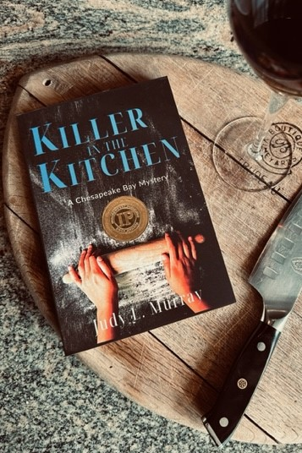
- What were your favorite scenes of the book? Why?

- Did you race to the end, or was it more of a slow burn?

- Which of Helen’s relationships did you find the most enjoyable?

- Is Helen’s habit of consulting her Detection Club fun, interesting, thought-provoking? Did you learn something new about her famous sleuths?

- Did you find the home shopping network scenes interesting as a location for murder and conflict?

- What did you like most about Helen? Can you identify with her? In what way?

- Great characters make great stories. Were the characters engaging and emotionally complex? Do you have favorites?

- Are you happy or frustrated with Helen and Joe’s relationship progress?

- Were you kept thinking and deducing throughout the story?

- Did the Realtor assaults sub-plot add to the overall story’s complexity?

- What plot twists surprised you or changed the direction of the mystery? Did any red herrings throw you off track? Did you pick up on clues, or were, ahem, surprised? What surprised you most?

- Did you reread any passages? If so, which ones? Are there any standout sentences, passages or descriptions? Did reading the book impact your mood? If yes, how so?

- Mystery-suspense novels build to the big reveal and final confrontation. Was the murderer’s motive believable? Was the final scene with the killer as exciting as in Murder in the Master Book One?

- Good mysteries leave an impression on the reader. Were there any scenes, descriptions, or dialogue you found especially interesting or revealing? Which ones made you smile or even laugh out loud?

- What do you think of Joe returning Andy’s ring to Helen? Should she continue to wear it?

- The goal of every novel is to provide you with enjoyment. Overall, did you enjoy this book? Would you recommend this series to others? Have you?

- Would you consider posting a review for the author?

- If you could ask the author anything, what would it be?

